**Lesson Notes**

1. What is the main purpose of an Operating System?
2. Simpler / More Efficient Application Programs
   * Operating System handles the Computer Hardware
   * Operating System handles resource allocation
   * Consistent User Experience
   * Operating System provides a standard User Interface (Windows)
   * Operating System provides a standard way to store and browse data files and folders (File Explorer)
   * Allow Multiple Applications Running At Same Time
   * Operating System Provides Ownership Control (User Accounts)
   * Operating System Schedules the CPU (Task Sharing)
3. What is the difference between Operating System Software and Use Application Software?

* Hardware Independence
  + Same applications can run on different computer hardware
  + Operating System must be configured according to hardware components present in the computer
  + User Interface
  + Applications focus on what is contained and displayed within a window
  + Operating System controls opening / closing / resizing windows and responding to mouse and keyboard actions
  + Operating System provides standard ways to print, save and open files, access the internet, etc.
  + Resource Allocation
  + Applications just ask for what they need (e.g. Memory, Disk Space)
  + Operating System checks for availability and access permission
  + Operating System coordinates resource allocation between applications

1. What is the difference between Operating System Software and Computer Hardware?

The operating system is simpler and more efficient while the hardware independence can run on many different computer hardware’s.

1. What are the main parts of an Operating System?

* Graphical User Interface (GUI)
  + Manages Windows Display, mouse, keyboard, sound, etc. and provides feedback to user application programs through system calls.
  + System Calls
  + Allows user application programs to access Operating System resources
  + Allows Operating System to provide feedback to user programs
  + Device Drivers
  + Converts a basic function (e.g. Display a Pixel) to detailed commands for a specific make and model of hardware (e.g. Nvidia GeForce RTX 2070)
  + I/O Manager
  + Schedules access to input / output devices (e.g. disk drive) to avoid conflicts between user applications

1. What are some popular operating systems?

* Windows OS
  + PCs / Laptops / Tablets
  + Mac OS
  + PCs / Laptops
  + Linux / Unix
  + PCs / Laptops / Phones / Embedded Devices
  + Android / Chrome
  + Phones / Tablets / Embedded Devices
* iOS
  + Phones / Tablets
* z/OS
  + IBM Mainframe Computers

**Reference Diagram**

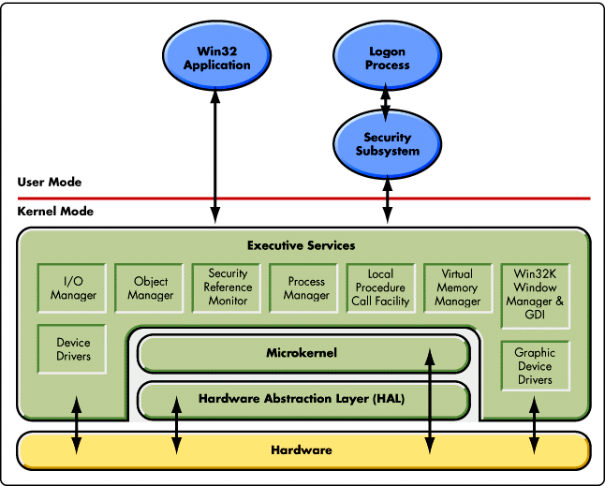

**Student Questions**

1. What is a device driver?
   1. Provide a brief summary

A device driver is a software [program](https://searchsoftwarequality.techtarget.com/definition/program) that controls a particular type of hardware [device](https://whatis.techtarget.com/definition/device) that is attached to a computer. When buying an [operating system](https://whatis.techtarget.com/definition/operating-system-OS), many device drivers are built into the product. However, if a user later buys a new type of device that the operating system did not anticipate, the new device driver will have to be installed. A device driver essentially allows smooth communication between a connected hardware device and the operating system ([OS](https://whatis.techtarget.com/definition/operating-system-OS)).

* 1. List some devices that require a device driver.

Hardware that uses a device driver to connect to a computer include printers, displays, CD-ROM readers, network or sound cards, computer mice or hard disks

* 1. Provide a label on the reference diagram for the location of a device driver for your graphics card.

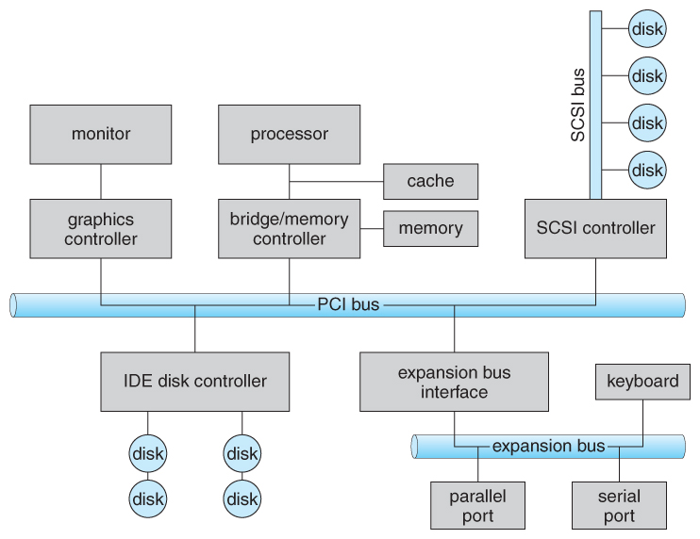

* 1. Provide a label on the reference diagram for the location of a device driver for a locally attached printer.

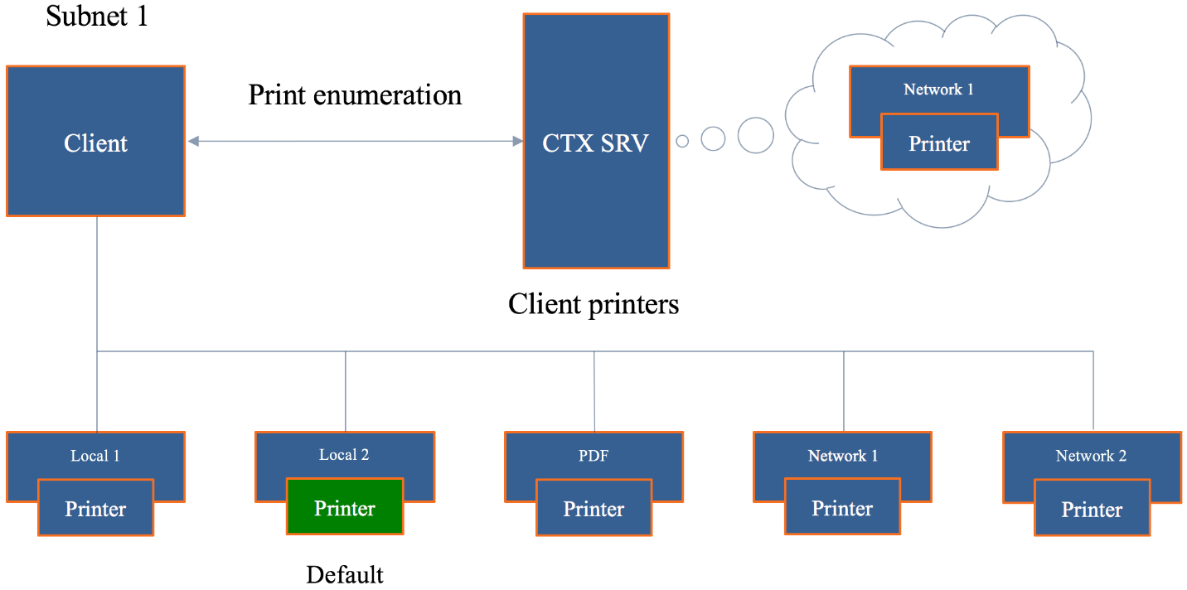

1. What is a DLL?
   1. Provide a brief summary

DLL files are nothing more than a means for developers to use shared code and data, allowing to upgrade functionalities without the need to re-link or re-compile applications. In other words, DLL files contain code and data that is used by several different applications

* 1. Explain how DLLs are related to user application programs

DLL’s store information or code as the same thing as user application programs

* 1. Provide a label on the reference diagram for the location of a DLL

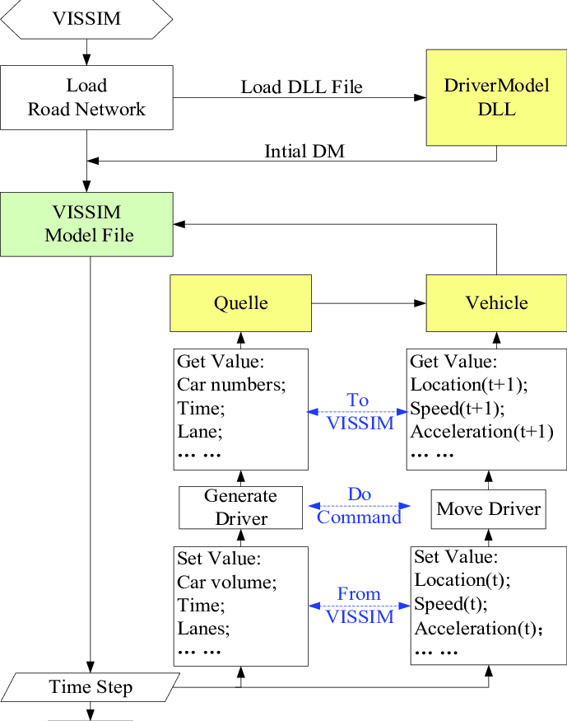

1. What is a windows manager?
   1. Provide a brief summary

Desktop Window Manager (dwm.exe) is a compositing window manager that renders all those pretty effects in Windows: transparent windows, live taskbar thumbnails, Flip3D, and even high resolution monitor support.

* 1. Explain how a windows manager is related to user application programs

A windows manager and a user application are related as they both process

* 1. Provide a label on the reference diagram for the location of a DLL

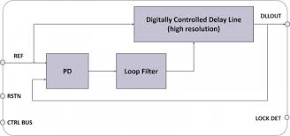

1. What is the windows task manager?
   1. Provide a brief summary

Windows Task Manager enables you to monitor the applications, processes, and services currently running on your PC. You can use Task Manager to start and stop programs and to stop processes, but in addition Task Manager will show you informative statistics about your computer's performance and about your network

* 1. List and explain four (4) types of system information provided by the task manager
* **Processes**: A list of running applications and background processes on your system along with CPU, memory, disk, network, GPU, and other resource usage information.
* **Performance**: Real-time graphs showing total CPU, memory, disk, network, and GPU resource usage for your system. You’ll find many other details here, too, from your computer’s [IP address](https://www.howtogeek.com/341307/how-do-ip-addresses-work/) to the model names of your computer’s CPU and GPU.
* **App History**: Information about how much CPU and network resources apps have used for your current user account. This only applies to new Universal Windows Platform (UWP) apps—in other words, [Store apps](https://www.howtogeek.com/243559/why-desktop-apps-arent-available-in-the-windows-store-yet/)—and not traditional Windows desktop apps (Win32 applications.)
* **Startup**: A list of your startup programs, which are the applications Windows automatically starts when you sign into your user account. You can disable startup programs from here, although you can also do that from Settings > Apps > Startup.
  1. Provide a label on the reference diagram for the operating system components related to each type of information.